Week Nine Questions
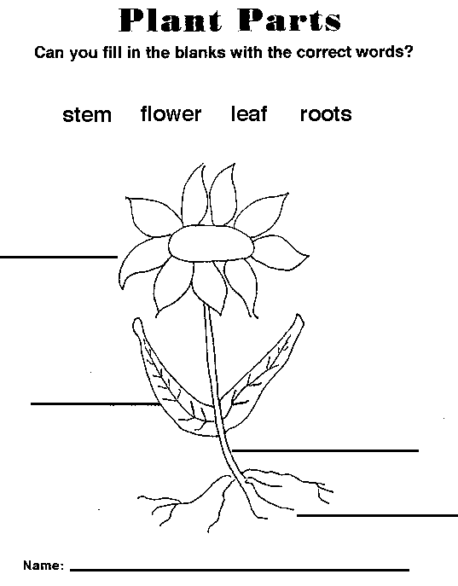
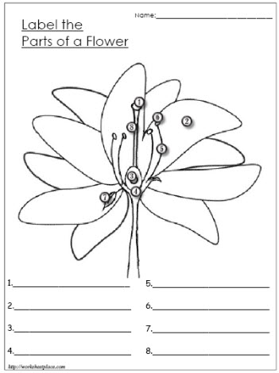
13. What part of the plants makes food?
a. leaves b. stem c. roots

14. What is the purpose of a plant’s flower?

15. What gas to plants release into the air?

16. What part of the plant stores food?

17. What is the green pigment in leaves that helps the plant make food?

18. What are two things that plants produce?

19. What is the name of your favorite plant?

20. You have discovered a new plant make up its common name and write its scientific name.

Week Ten Worksheet
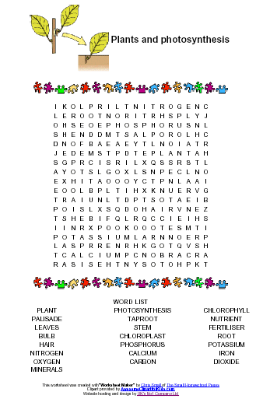

Week Eleven Questions
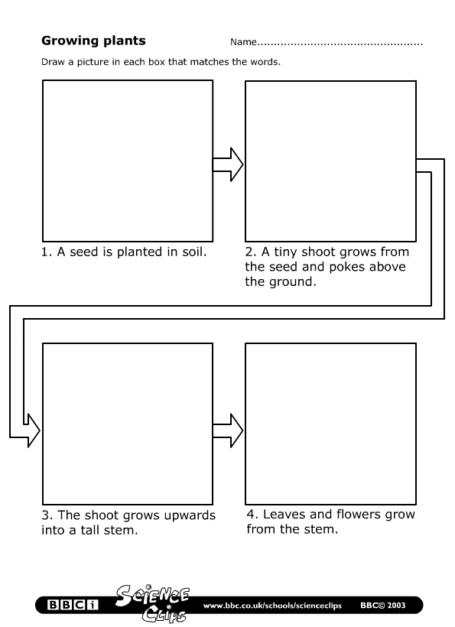
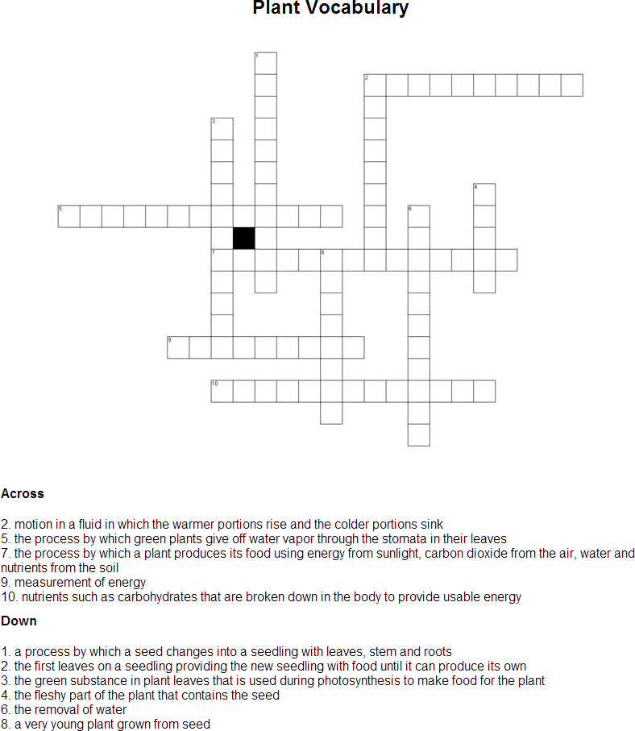

- Write a paragraph describing different ways you can help the Earth.

