Week Five Question
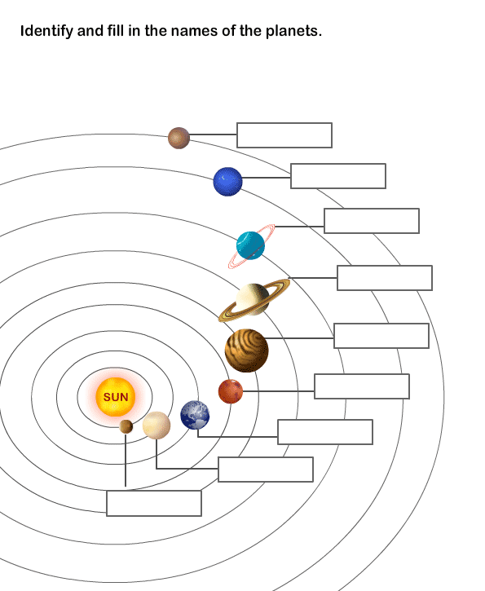
10. What is the name of our solar system?

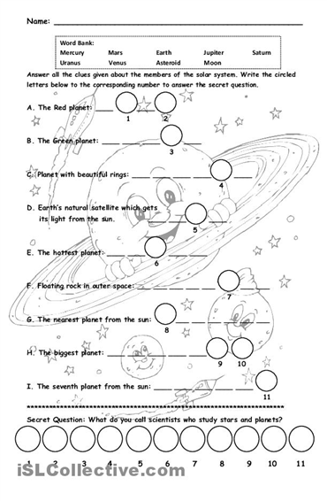

Week six Questions
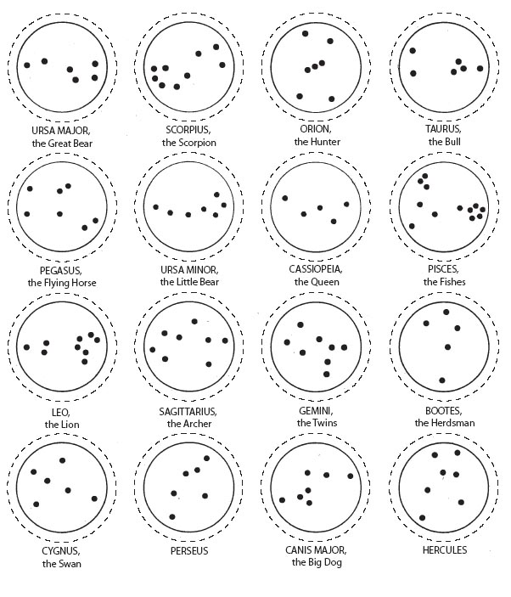
17. True or False. Greeks used stars and constellations to tell stories.

18. What do stars consist of?

19. True or False. Stars are super close that’s why we can see them so well.

20. True or False. Stars look the same all the seasons of the year.
Week Seven Questions

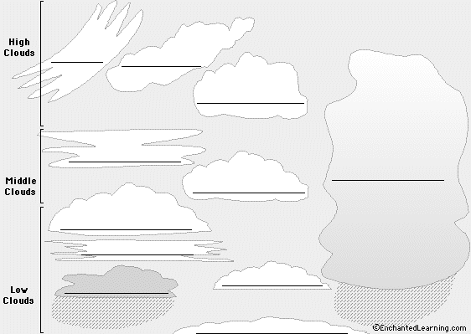

12. What are clouds made of?

13. What chemicals make up our atmosphere?

14. What are the layers of the Earth’s atmosphere?
15. What chemicals make up water?

16-20. Draw the Earth and its layers of atmosphere.

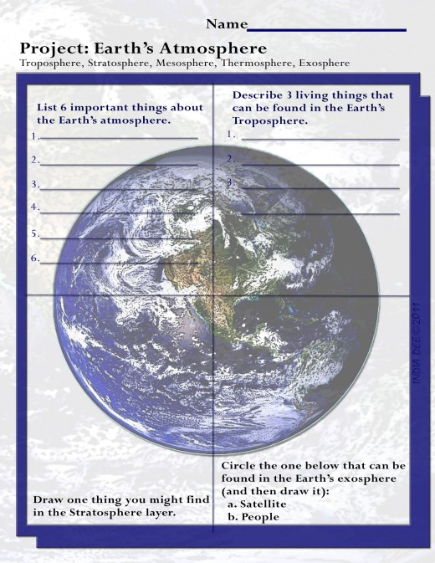
Week Eight Questions

12-20. Draw, Label, and Describe the water cycle.

