Week One Questions
Name ________________________ | Date ____________________

Parts of An Atom

Directions:
Label the parts of the atom pictured below. Make sure to include all of the words in the word bank.

Electron, Nucleus, Neutron, Proton, Orbit (Shell)

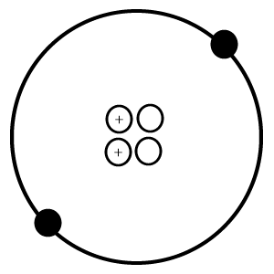

Name the three kinds of matter:
- .
- .
- .
Write and draw an example of a solid: .
Write and draw an example of a liquid: .
Write and draw an example of a gas: .

15. What does all matter have?

16. Protons are positive, negative or neutral?

17. Neutrons are positive, negative or neutral?

18. Electrons are positive, negative or neutral?

19. What is the smallest unit of an element without losing the elements properties?

20. List an element.

Week Two Question Name:
True/False
- If an object is larger than another, than the larger object weighs more. .
- All matter has mass. .
- Gas molecules are tightly packed together. .
- A compound is made up of two or more elements. .
- Neutrons are positive. .
List 13 Elements
6.
7.
8.
9.
10.
11.
12.
13.
14.
15.
16.
17.
18.
List your favorite food and your favorite dessert and describe if it is a solid, liquid, or a gas?

Week Three Questions Name:
1. volume | something that represents something else, esp. a material sign or object that stands for a complex or abstract concept:
2. element | made up of two or more parts or elements.
3. symbol | A combination of two or more substances mixed together.
4. mixture | the state if compactness of a material.
5. molecule | Two or more atoms together that form the smallest particle.
6. compound | A small particle that carries one unit of negative energy.
7. neutron | a collection of pages of writing or print bound together; book.
8. electron | A small particle that is neutrally charged, but has mass.
9. density | a part of any whole.
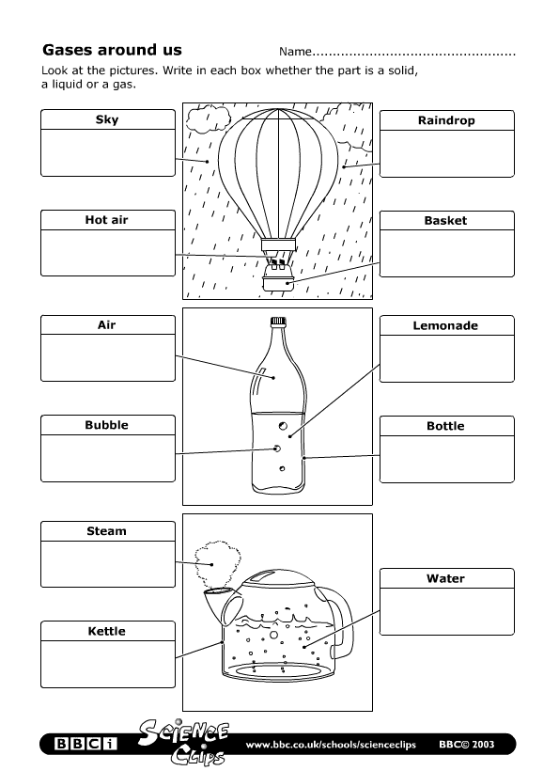

Week Four Questions
